Project Design Phase
Solution Architecture

Date | 15 February 2026
Team ID | LTVIP2026TMIDS24256
Project Name | Heritage Treasures: An In-Depth Analysis of UNESCO World Heritage Sites in Tableau
Maximum Marks | 4 Marks

Solution Architecture:
Solution architecture is a complex process – with many sub-processes – that bridges the gap between business problems and technology solutions. Its goals are to:
- Find the best tech solution to solve existing business problems.
- Describe the structure, characteristics, behavior, and other aspects of the software to project stakeholders.
- Define features, development phases, and solution requirements.
- Provide specifications according to which the solution is defined, managed, and delivered.

Example - Solution Architecture Diagram:


Figure 1: Architecture and data flow of the voice patient diary sample application
Reference: https://aws.amazon.com/blogs/industries/voice-applications-in-clinical-research-powered-by-ai-on-aws-part-1-architecture-and-design-considerations/

Solution Architecture Overview
The solution architecture for Heritage Treasures: An In-Depth Analysis of UNESCO World Heritage Sites in Tableau bridges the gap between raw heritage data and meaningful business insights through a structured, scalable, and web-integrated analytics system.
The architecture follows a 3-Tier Model:
- Presentation Layer (User Interface Layer)
- Application Layer (Processing & Visualization Layer)
- Data Layer (Storage Layer)

Architectural Components
1. Presentation Layer (Frontend)
This layer is responsible for user interaction.
Components:
- Web Browser
- Flask Web Interface
- Embedded Tableau Dashboard
Function:
- Users access dashboards online.
- Apply filters (Region, Category, Danger Status).
- View trends and forecasting insights.

2. Application Layer (Business Logic & Visualization)
This is the core processing layer.
Components:
- Tableau Desktop
- Tableau Public
- Python Flask Framework
Function:
- Data cleaning and transformation.
- Creation of calculated fields.
- Forecasting and aggregation.
- Dashboard and Story generation.
- Publishing to Tableau Public.
- Routing and rendering through Flask.
3. Data Layer (Storage)
This layer stores structured data.
Components:
- UNESCO World Heritage CSV Dataset
- Tableau Workbook (.twb / .twbx)
- Tableau Public Cloud Storage
Function:
- Stores heritage site metadata.
- Maintains processed visualization files.
- Hosts published dashboards online.
Architecture Flow (Step-by-Step Data Flow)
- The UNESCO dataset is downloaded from Kaggle.
- The dataset is uploaded into Tableau Desktop.
- Data is cleaned and prepared.
- Visualizations are created (Treemap, Pie Chart, Line Chart, Bar Charts).
- Dashboards and Stories are built.
- Dashboards are published to Tableau Public Cloud.
- The Tableau Public link is embedded into a Flask web application.
- Users access the dashboard through a web browser.
- Filters and interactions dynamically update visualizations.

Solution Architecture Diagram (Text Representation for Drawing)
You can draw the diagram in your record as follows:
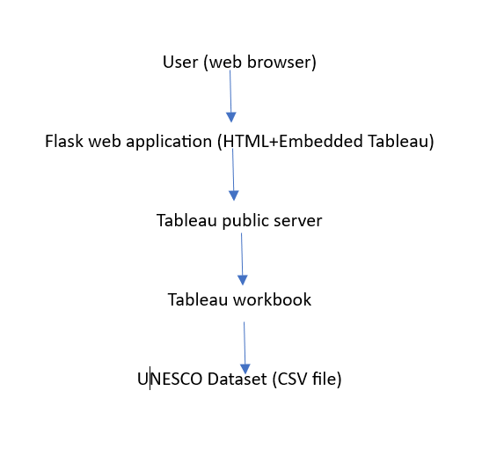
Add arrows showing:
- User Interaction Flow
- Data Processing Flow
- Cloud Hosting Flow

Key Architectural Characteristics
✔ Scalable
Future datasets or additional UNESCO updates can be integrated without redesigning the system.
✔ Modular
Data layer, visualization layer, and web layer are independent.
✔ Cloud Integrated
Dashboards are hosted on Tableau Public for global access.
✔ Interactive
Users can dynamically filter and explore insights.

How This Architecture Solves the Business Problem
- Converts raw tabular data into interactive dashboards.
- Enables quick identification of endangered heritage sites.
- Provides forecasting for future inscriptions.
- Allows web-based access for stakeholders anywhere.
- Improves decision-making through data-driven insights.

